HOUSE PARTY

Admin panel

The welcome page contains the elements of login and signup, click the buttons accordingly!

* If you are a new user or an admin one must register your account
* In the registration page there are 3 elements where you need to fill in your details like, Email id, password and confirm password.
* One can also register with their social media accounts like Facebook and google.
* Need to add social media login backend authentication (firebase authentication for admin and vender page).
* If you already have an account, you can hit login button by filling in username and password.

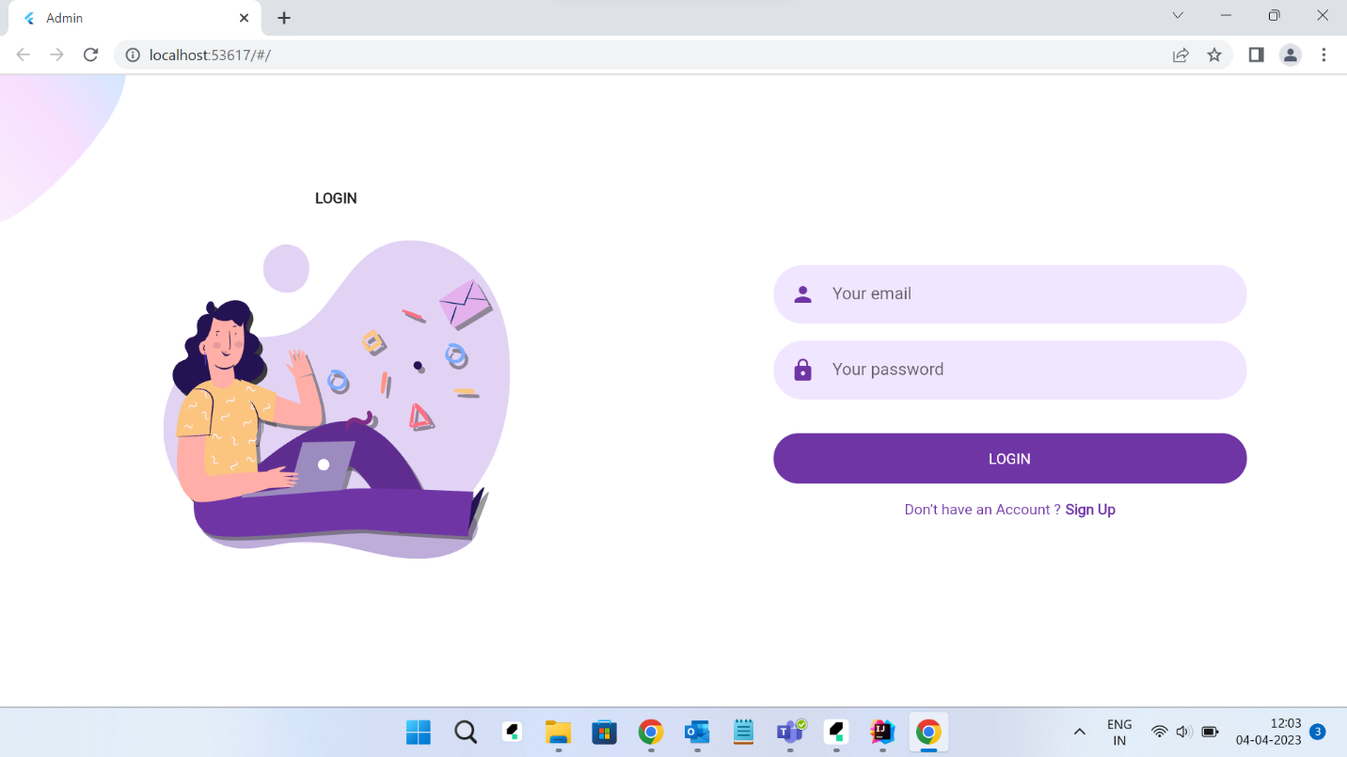

* Ones after successful login you will be redirected into a dashboard where you can see the entire details.
* As an admin you will have an entire authority to add vendors, remove a vendor.
* Also have an option to check the Reports (Graph and values)
* in the side bar will can see an option named Emails – where you can see the feedbacks and requests from vendors.

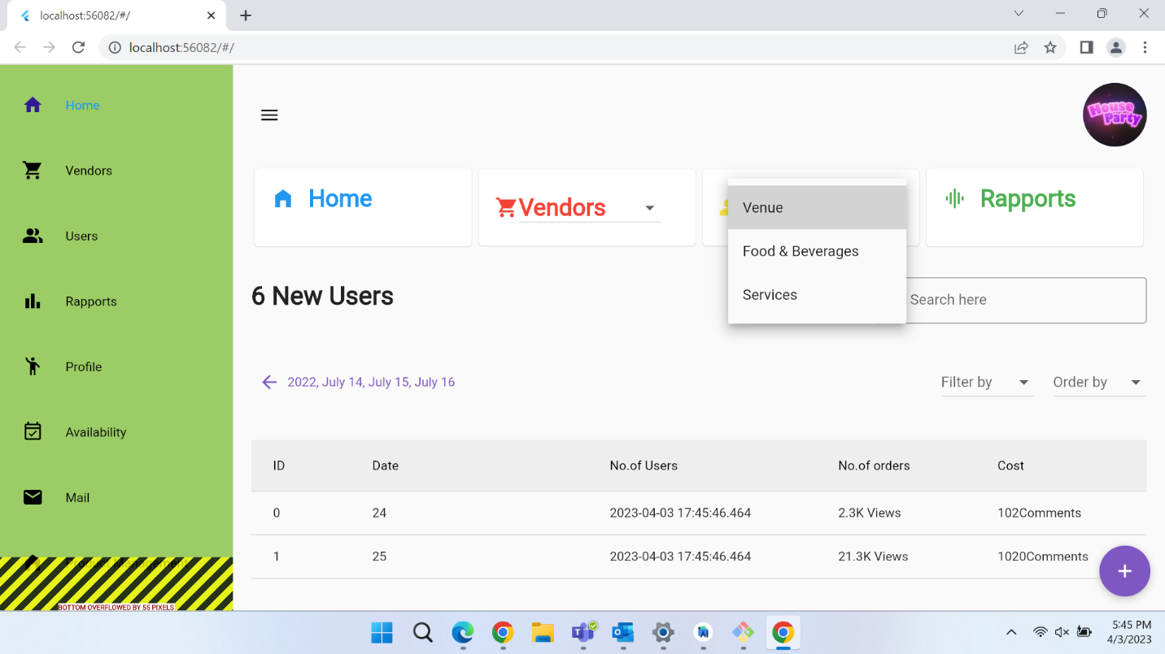

House Party Mobile application.

* House party mobile application is designed for end users (customers)
* One can download the application directly from google Play store or Appstore.
* After successful installation you can see the welcome page.
* If you have an account fill in the login details and click login or else, click create account at the bottom left of mobile screen.

* In sign up page you can directly register with your Email Id
* We can also login by using social media authentication (Google or Facebook).

Backend & Database

Mobile application

* For mobile applications we are using firebase database for saving the user login details.
* As it is a real-time database it will be automatically updated when a person registers.
* Here few examples of user data.

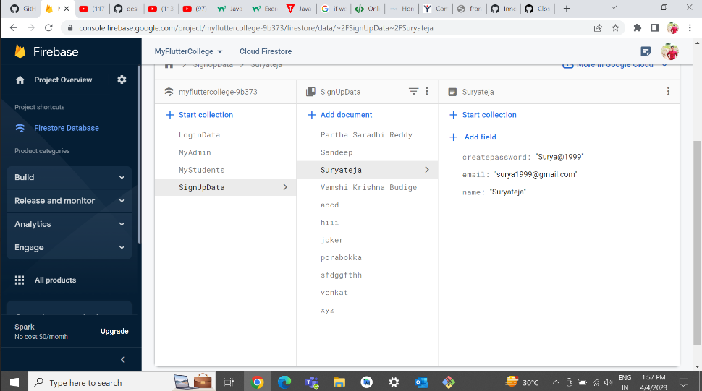

* We have used Cloud Firestore as a database to save admin and vendor login details.
* Example data for admin login data.

